# **1- Login to AWS and launch an instance**

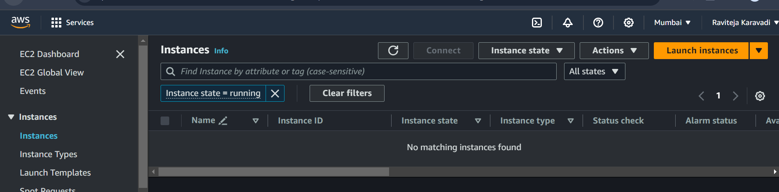

# **2- Select Ubuntu Server 20 LTS**

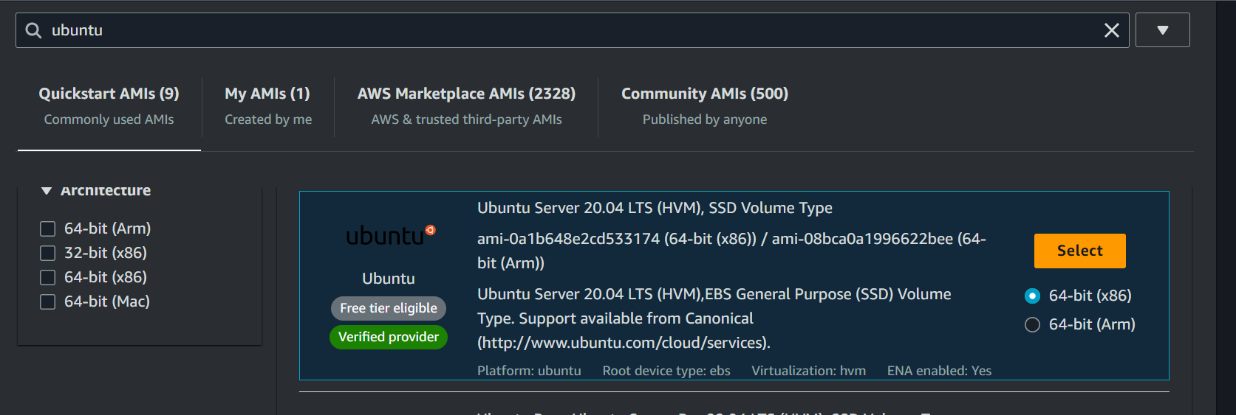

# **3- Choose an Instance Type (Choose recommended)**

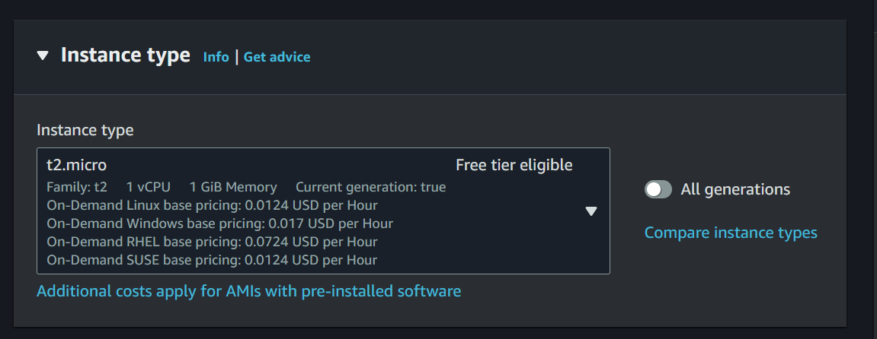

# **4- The instance Auto-assing Public IP has to be enable**

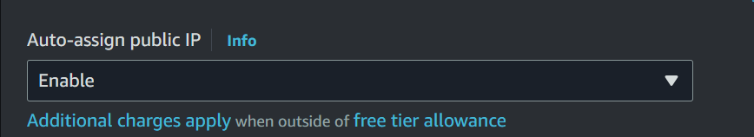

# **5- For larger size installations we can add additional volume**

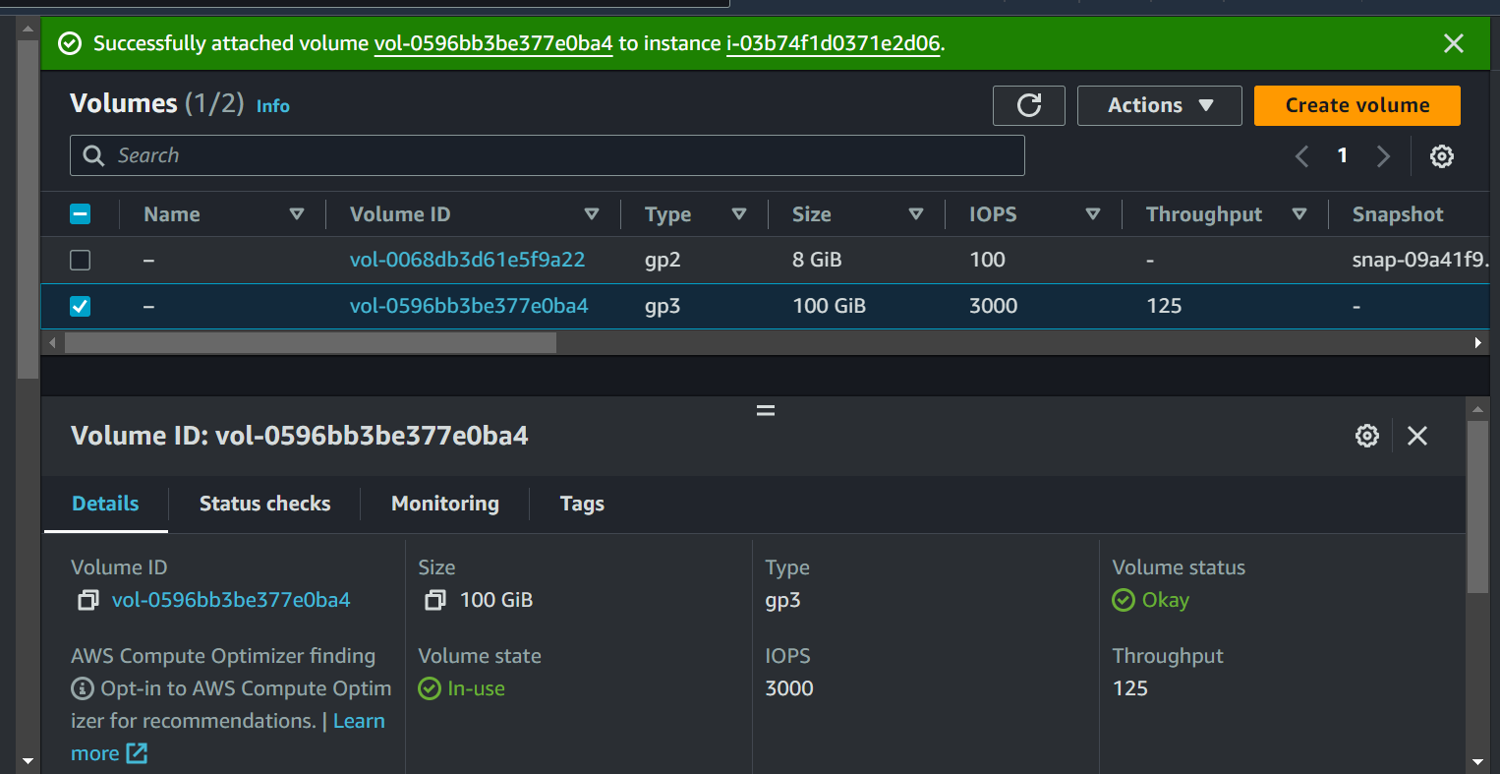

# **6- Make sure the security group type has all traffic allowed to inbound and outbound that you need**

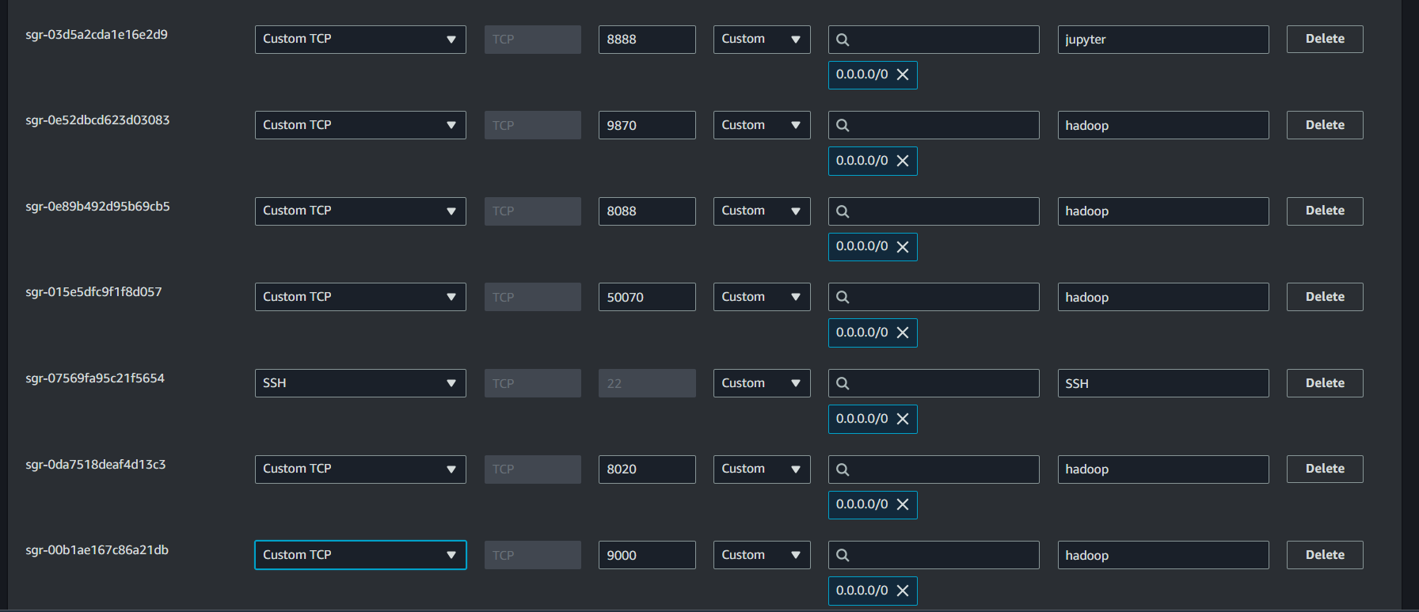

# **7- Create a Private Key file (.pem)**

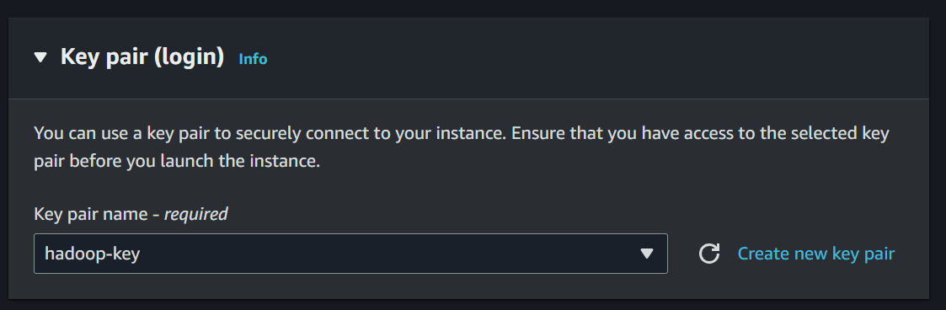

# **8- Launch the Instance**

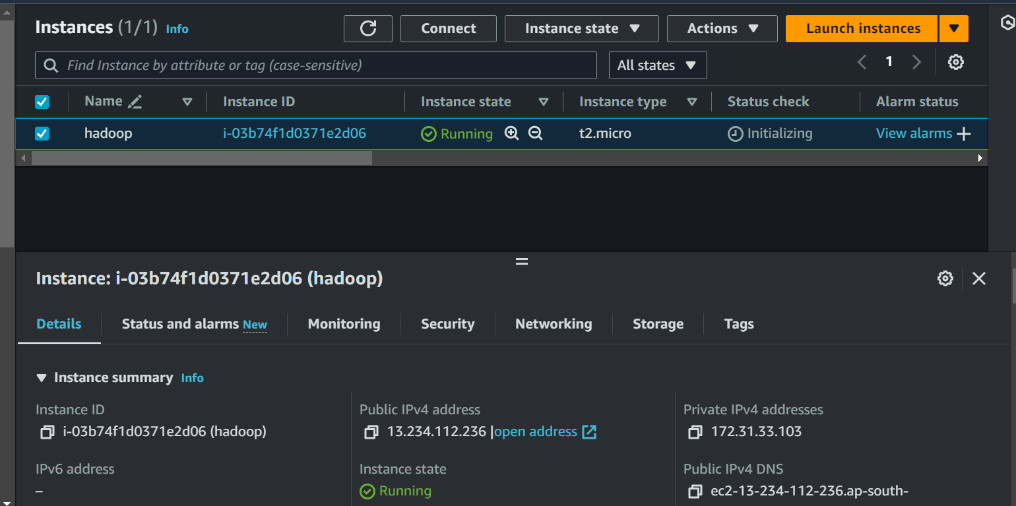

# **9- Assign Elastic IP to Instance**

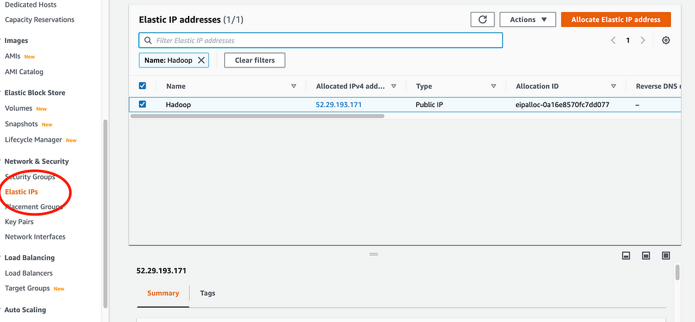

# **10- Associate the elastic IP to the Instance**

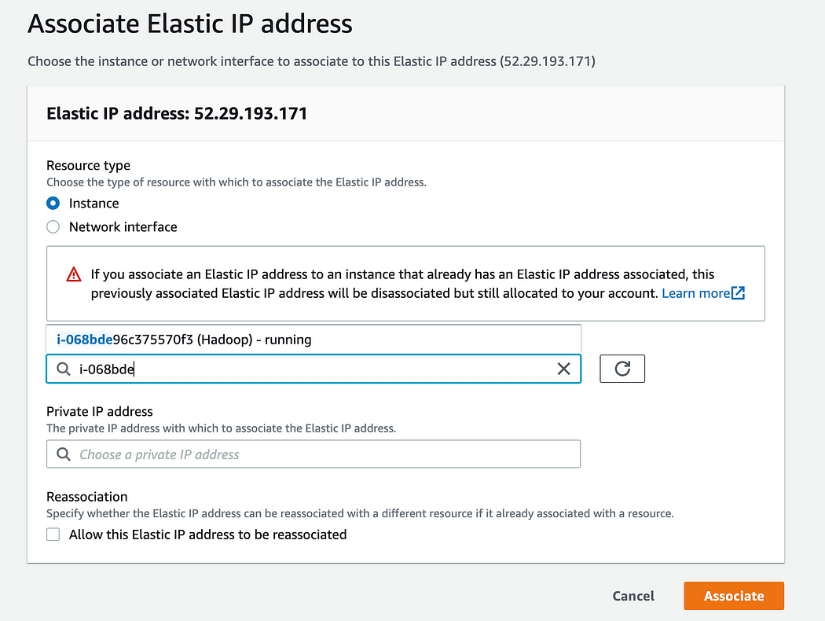

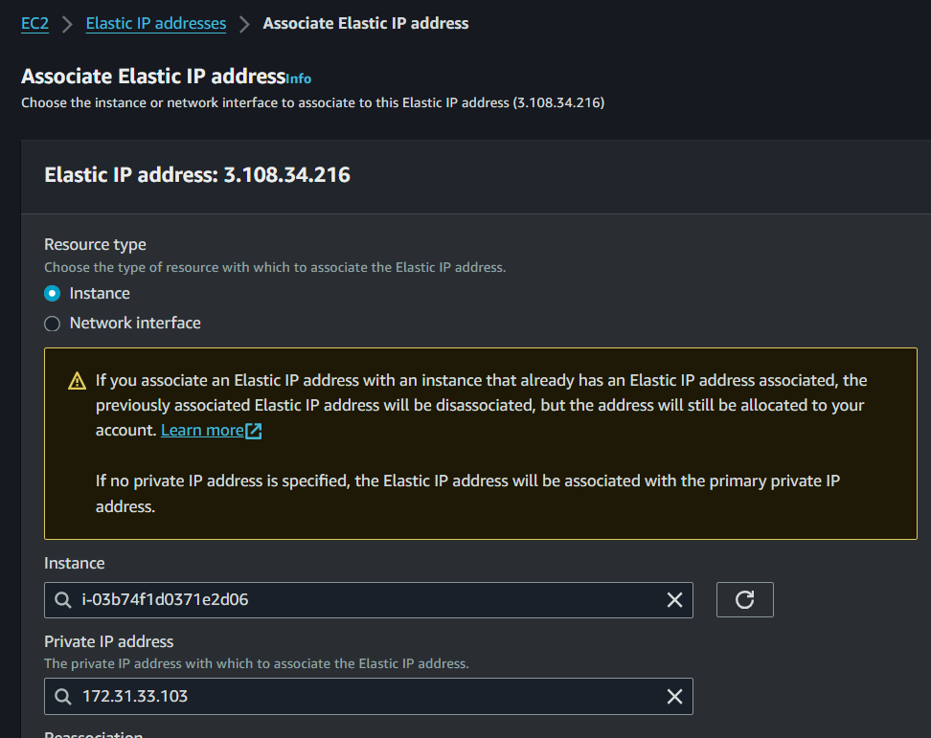

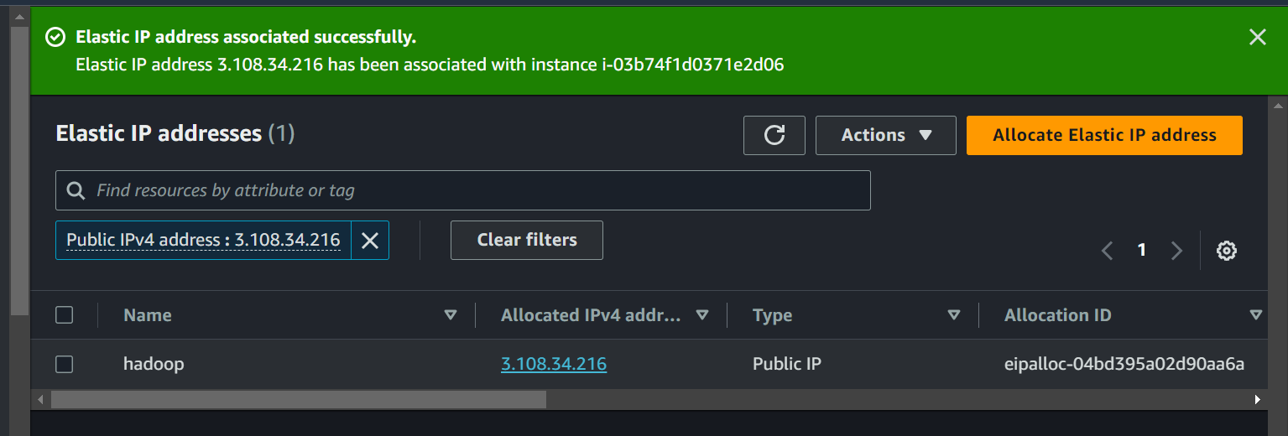

# **11- Connect using SSH**

SSH into EC2

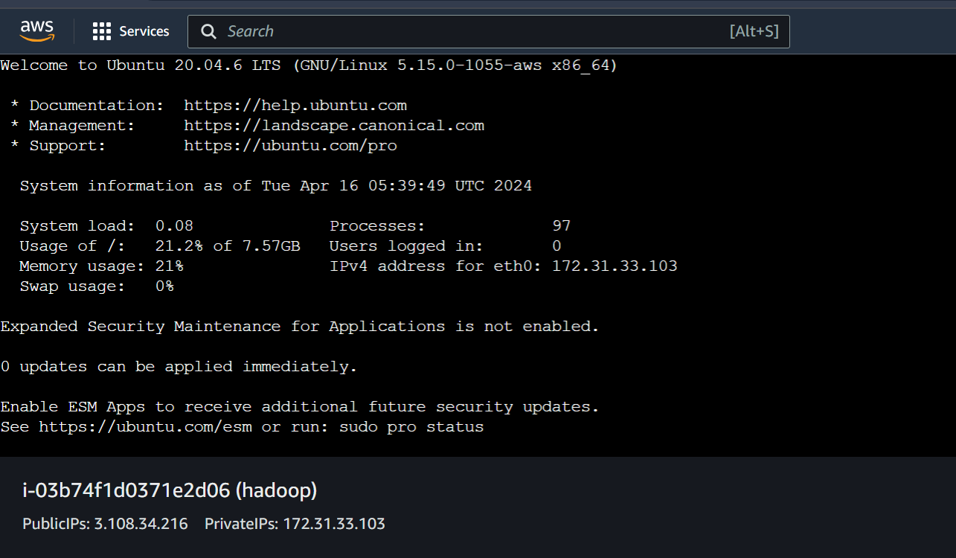

# **13- Update the packages**

sudo apt update

sudo apt upgrade

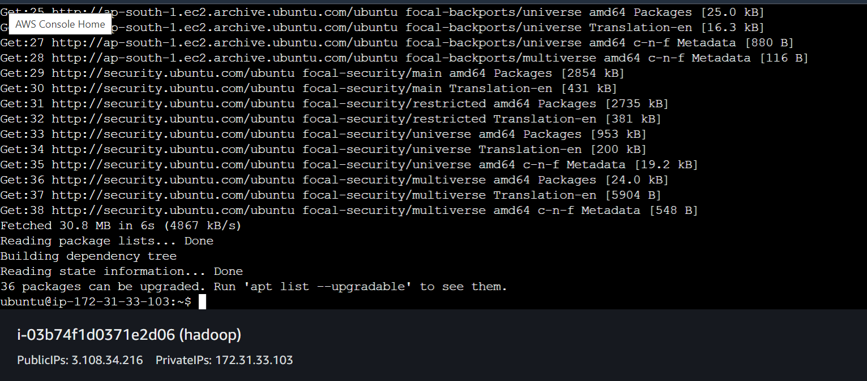

# **14- Change Hostname to hadoop**

sudo nano /etc/hostname

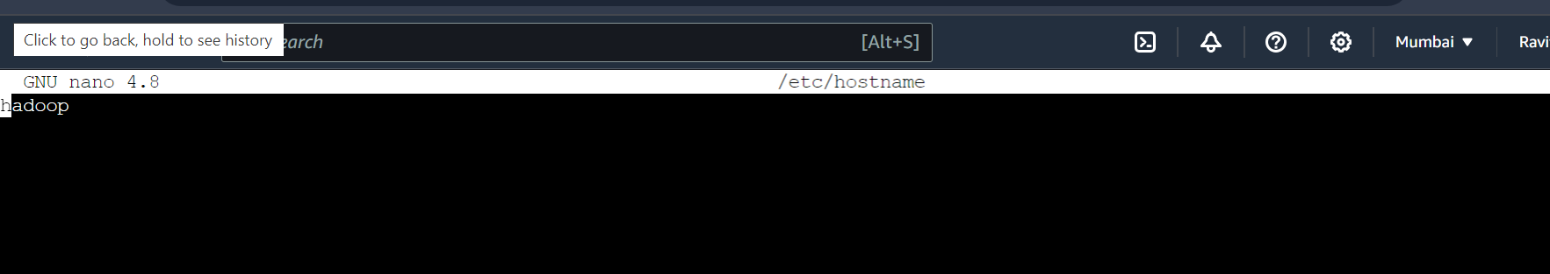

# **15- Reboot and then Reconnect to Instance**

sudo reboot

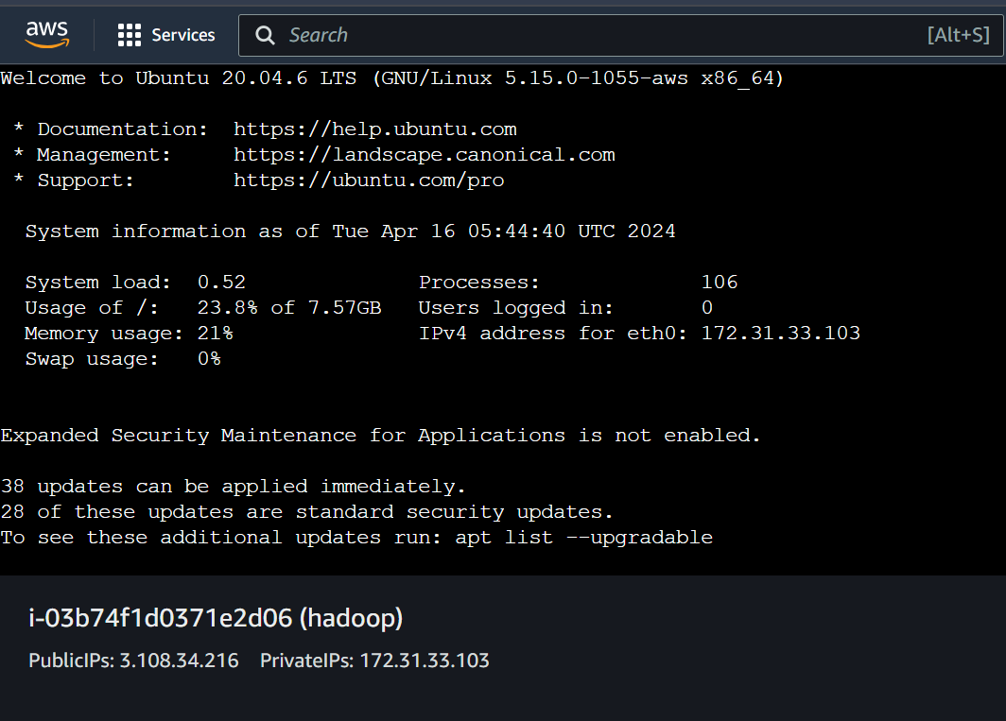

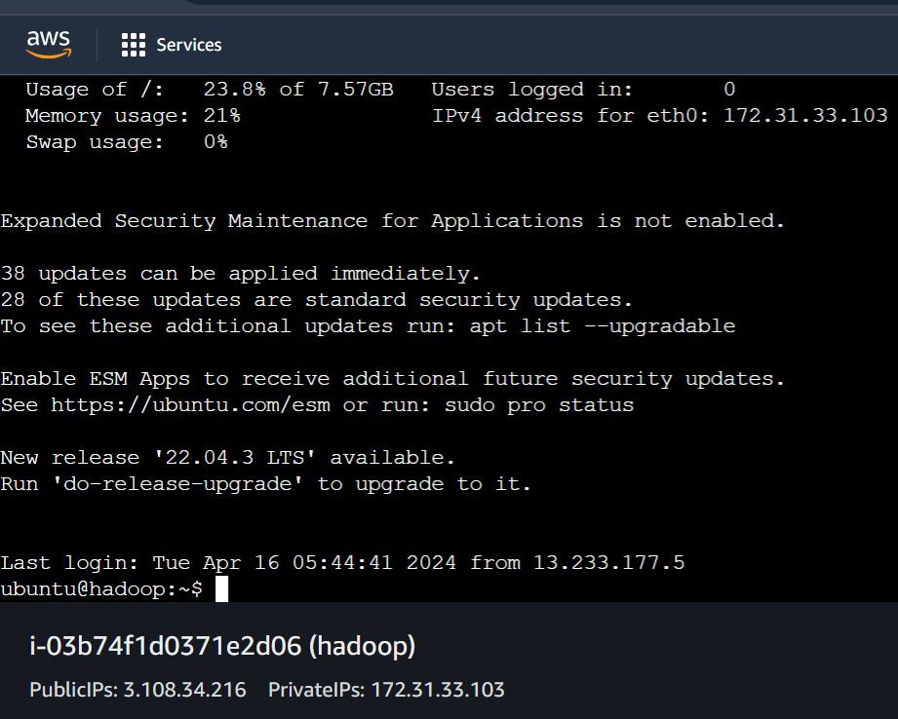

# **16- Install Open JDK 8**

sudo apt install openjdk-8-jdk

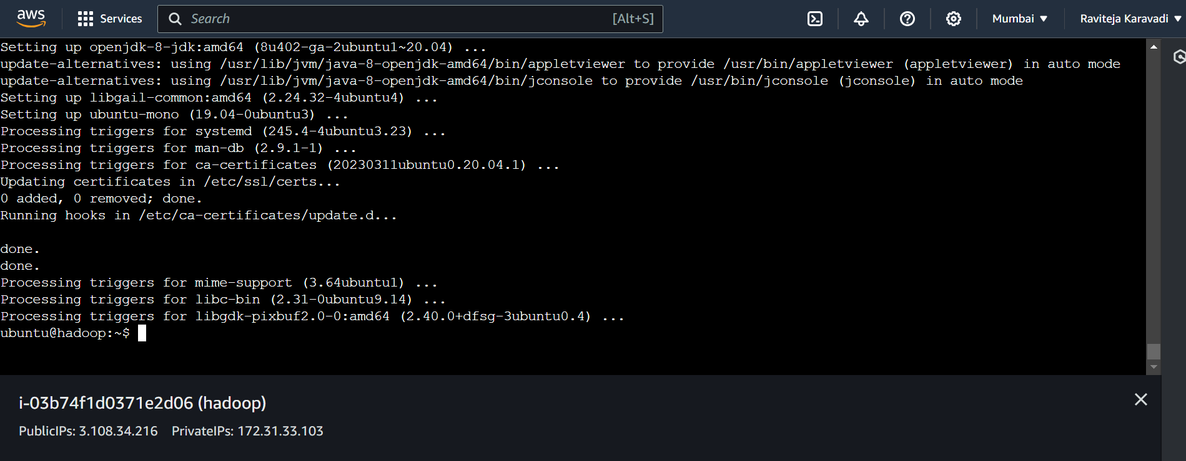

# **17- Download and Install Hadoop**

## **Go to Hadoop -> Downloads page**

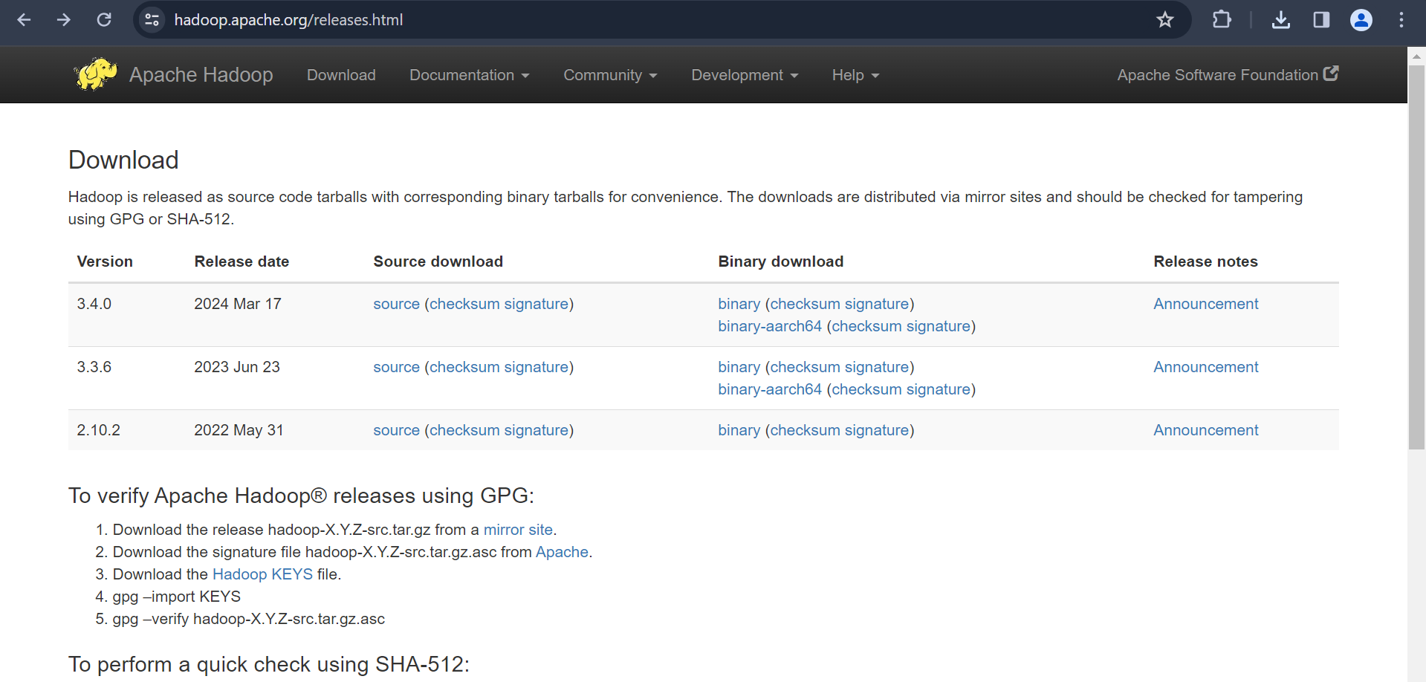

## **Install and extract the package**

wget <link>

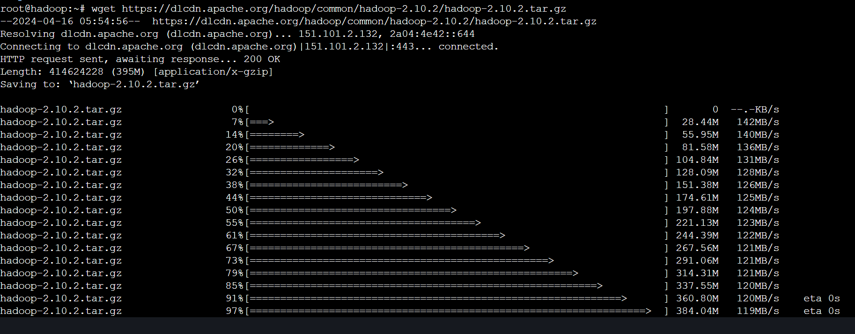

Extract

sudo tar zxvf hadoop-* -C /usr/local

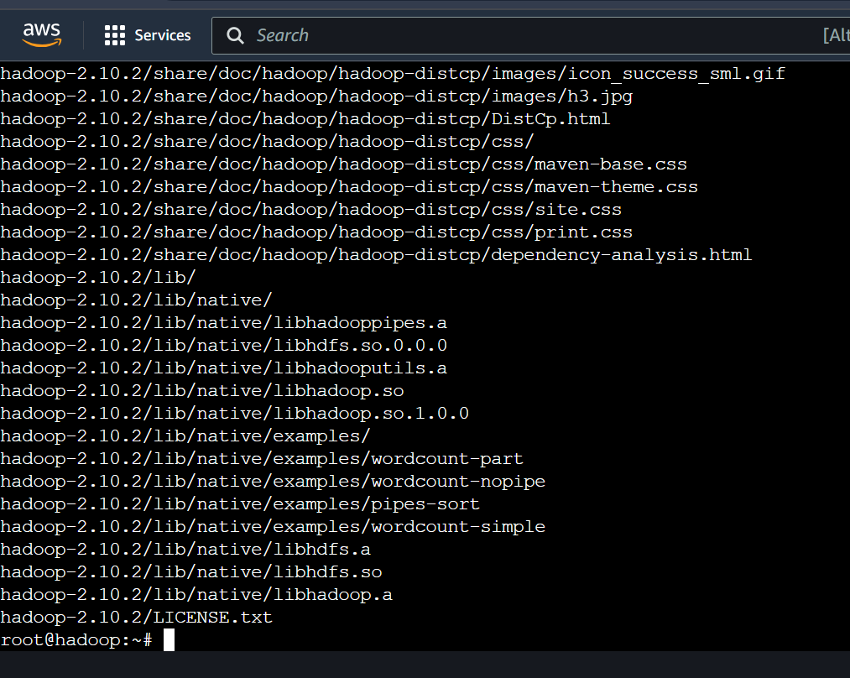

# **18- Rename the folder**

sudo mv /usr/local/hadoop-* /usr/local/hadoop

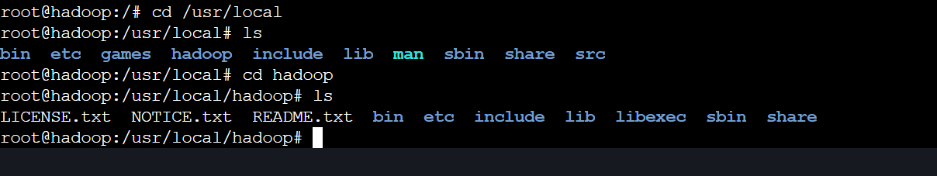

# **19- Setting up of Environment**

## **Open .bashrc file**

nano ~/.bashrc

Write into:

export HADOOP_HOME=/usr/local/hadoop

export HADOOP_INSTALL=$HADOOP_HOME

export HADOOP_MAPRED_HOME=$HADOOP_HOME

export HADOOP_COMMON_HOME=$HADOOP_HOME

export HADOOP_CONF_DIR=/usr/local/hadoop/etc/hadoop

export HADOOP_HDFS_HOME=$HADOOP_HOME

export YARN_HOME=$HADOOP_HOME

export HADOOP_COMMON_LIB_NATIVE_DIR=$HADOOP_HOME/lib/native

export PATH=$PATH:$HADOOP_HOME/sbin:$HADOOP_HOME/bin

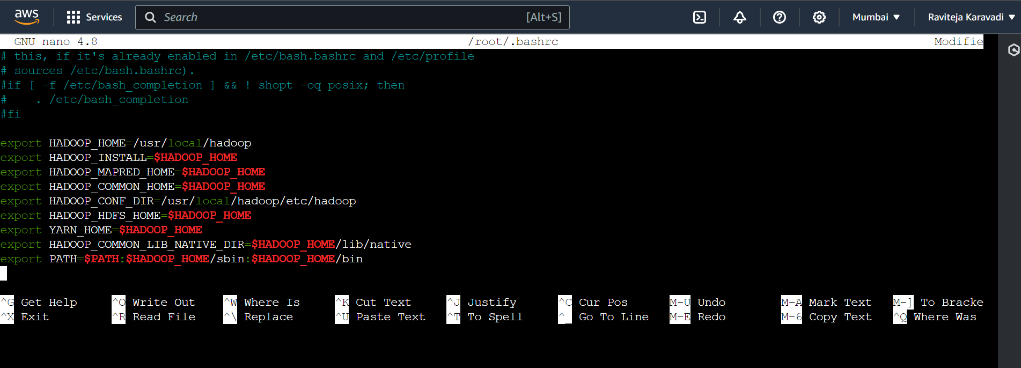

## **For reflecting to current session**

source ~/.bashrc

hadoo

## **Open hadoop-env.sh from $HADOOP_CONF_DIR and shChange Java Home and Hadoop Conf Dir as below**

sudo nano $HADOOP_CONF_DIR/hadoop-env.

export JAVA_HOME=/usr/lib/jvm/java-8-openjdk-amd64

export HADOOP_CONF_DIR=/usr/local/hadoop/etc/hadoop

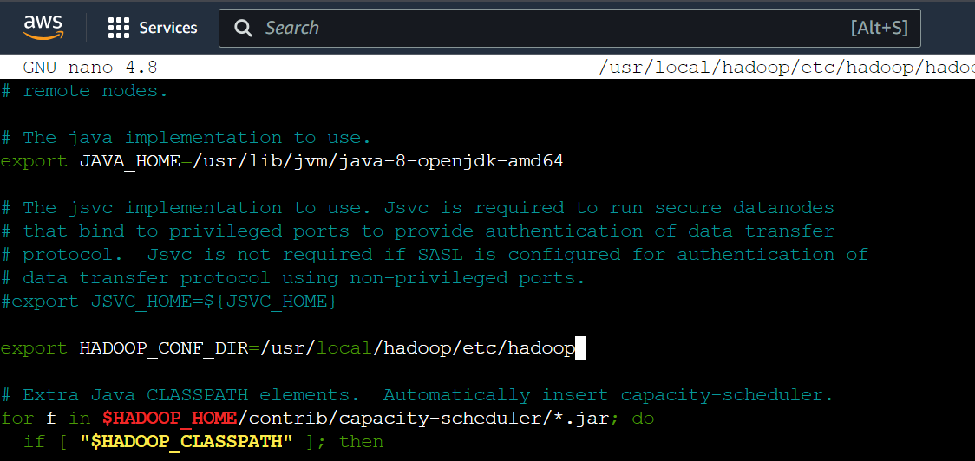

# **20- SSH Connection**

## **Upload <your_key_pair> file to .ssh directory (Open your local (not instance) and upload .pem from local to instance)**

## **Reconnect to instance and check .pem file load control**

ssh -i <pem file name> ubuntu@public-dns-name

ls

## **Copy <your_key_pair> to instance**

cp <pem file name> ~/.ssh/

For Windows:

Locate .ssh directory and perform the same

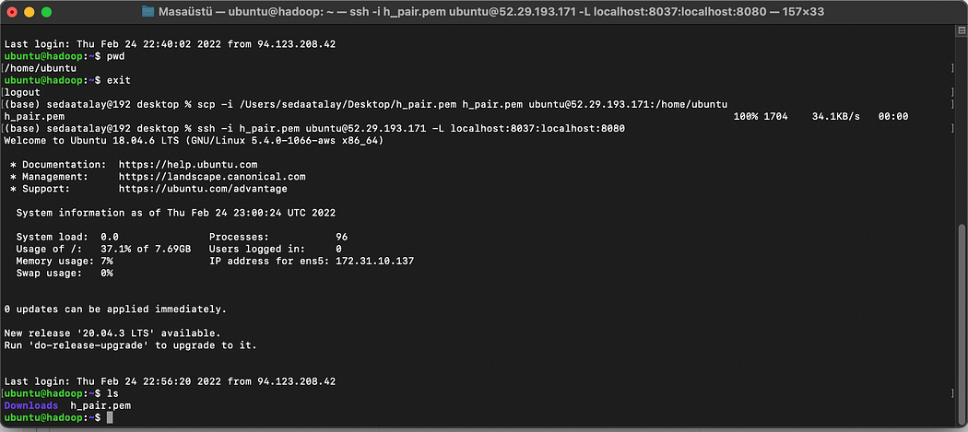

## **Create a config file in .ssh directory of local system (not Instance)**

nano ~/.ssh/config

Write into:

Host hadoop

HostName <publicDnsname>

User ubuntu

IdentityFile ~/.ssh/<pem file name>

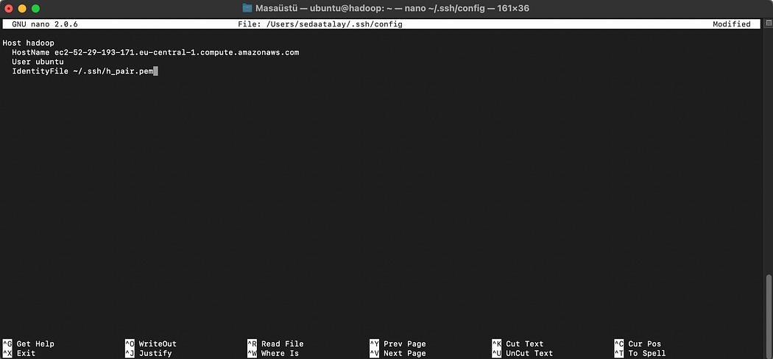



## **Copy the config and pem files to Instance .ssh directory**

scp ~/.ssh/config hadoop:~/.ssh

scp ~/.ssh/*.pem hadoop:~/.ssh

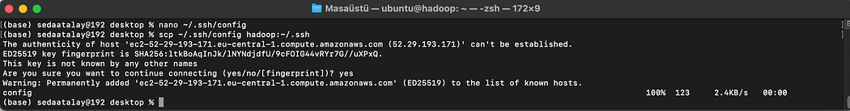

## **Reconnect to instance and create public key**

ssh -i <pem file name> ubuntu@public-dns-name

ssh hadoop

ssh-keygen -f ~/.ssh/id_rsa -t rsa -P ""

cat ~/.ssh/id_rsa.pub >> ~/.ssh/authorized_keys

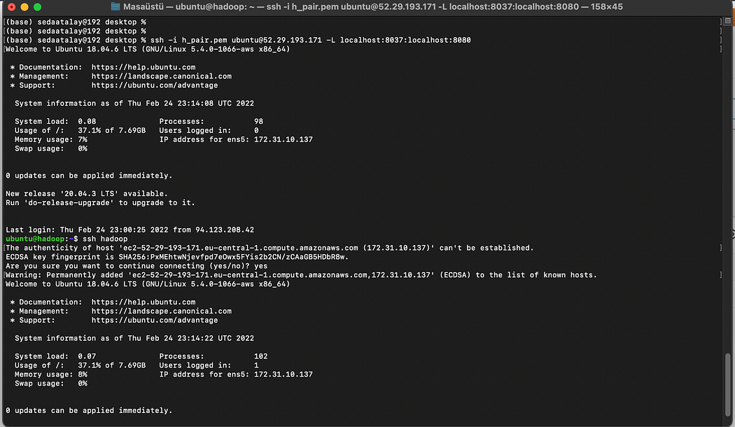

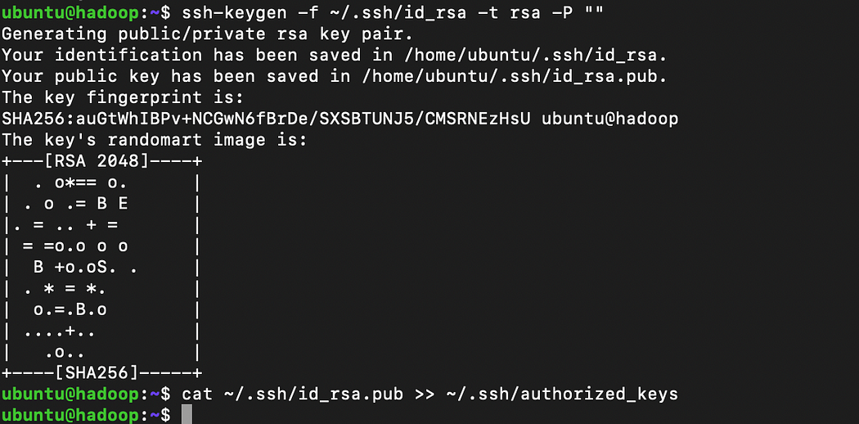

## **Open /etc/hosts and add instance IPV4 address with hostname**

sudo nano /etc/hosts

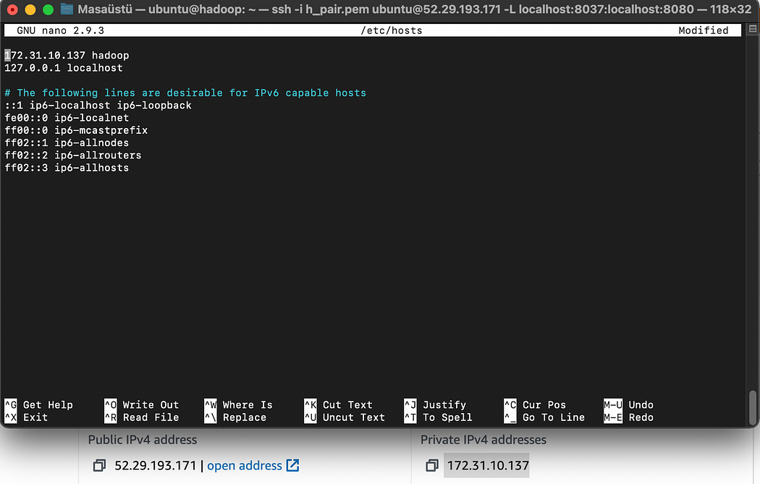

# **21- Hadoop Configuration**

## **Edit core-site.xml**

sudo nano $HADOOP_CONF_DIR/core-site.xml

Write into:

<configuration>

<property>

<name>fs.defaultFS</name>

<value>hdfs://<your public dns name>:9000</value>

</property>

</configuration>

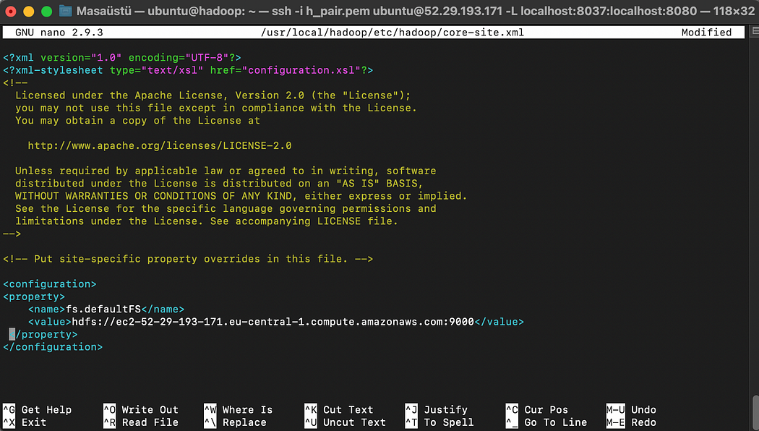

## **Edit yarn-site.xml**

sudo nano $HADOOP_CONF_DIR/yarn-site.xml

Write into:

<configuration>

<property>

<name>yarn.nodemanager.aux-services</name>

<value>mapreduce_shuffle</value>

</property>

<property>

<name>yarn.resourcemanager.hostname</name>

<value><your public dns name></value>

</property>

</configuration>

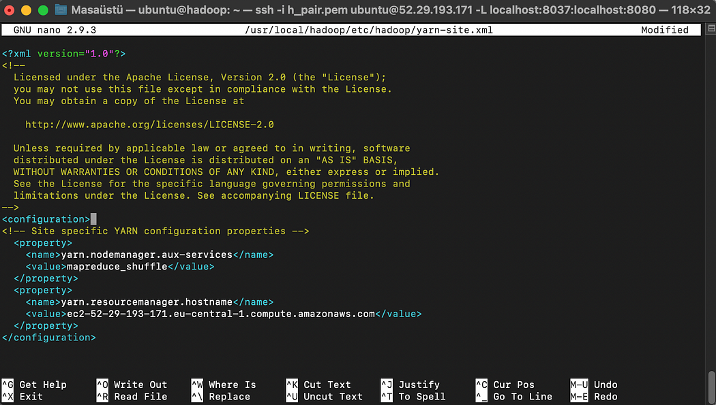

## **Edit mapred-site.xml from mapred-site.xml.template**

sudo cp $HADOOP_CONF_DIR/mapred-site.xml.template $HADOOP_CONF_DIR/mapred-site.xml

Write into:

<configuration>

<property>

<name>mapreduce.jobtracker.address</name>

<value><your public dns name>:54311</value>

</property>

<property>

<name>mapreduce.framework.name</name>

<value>yarn</value>

</property>

</configuration>

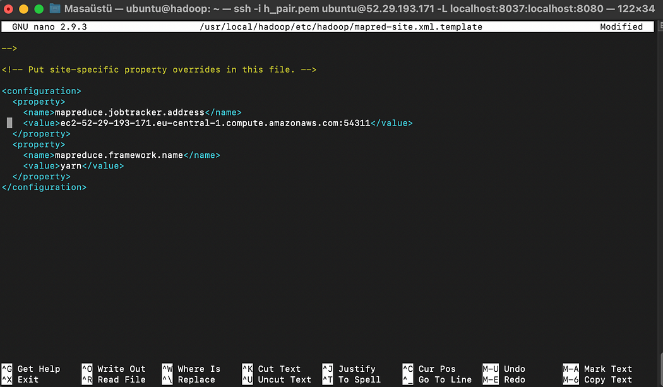

## **Edit hdfs-site.xml**

sudo nano $HADOOP_CONF_DIR/hdfs-site.xml

Write into:

<configuration>

<property>

<name>dfs.replication</name>

<value>1</value>

</property>

<property>

<name>dfs.namenode.name.dir</name>

<value>file:///usr/local/hadoop/data/hdfs/namenode</value>

</property>

<property>

<name>dfs.datanode.data.dir</name>

<value>file:///usr/local/hadoop/data/hdfs/datanode</value>

</property>

</configuration>

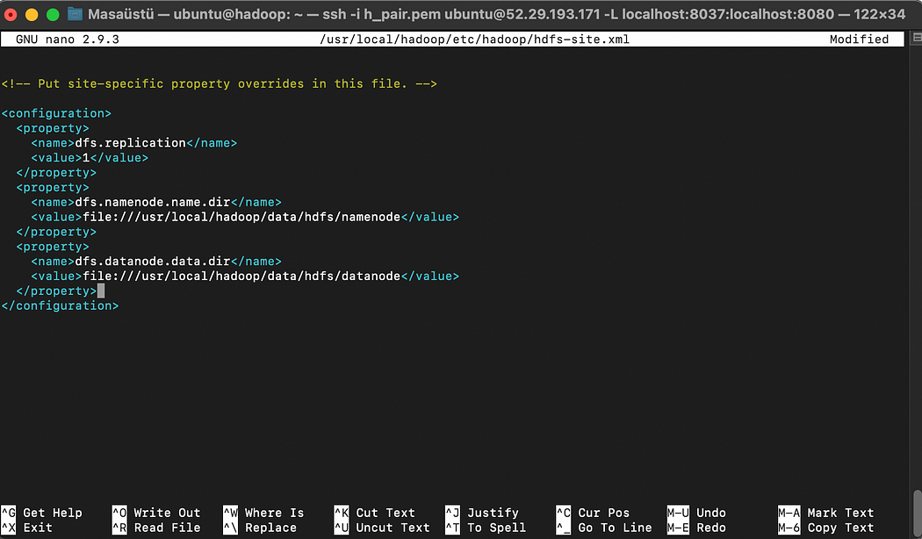



## **Make namenode and datanode directories**

sudo mkdir -p $HADOOP_HOME/data/hdfs/namenode

sudo mkdir -p $HADOOP_HOME/data/hdfs/datanode

## **Change the owner**

sudo chown -R ubuntu $HADOOP_HOME

## **Change masters and slaves to hadoop**

sudo nano $HADOOP_HOME/masters

sudo nano $HADOOP_HOME/slaves

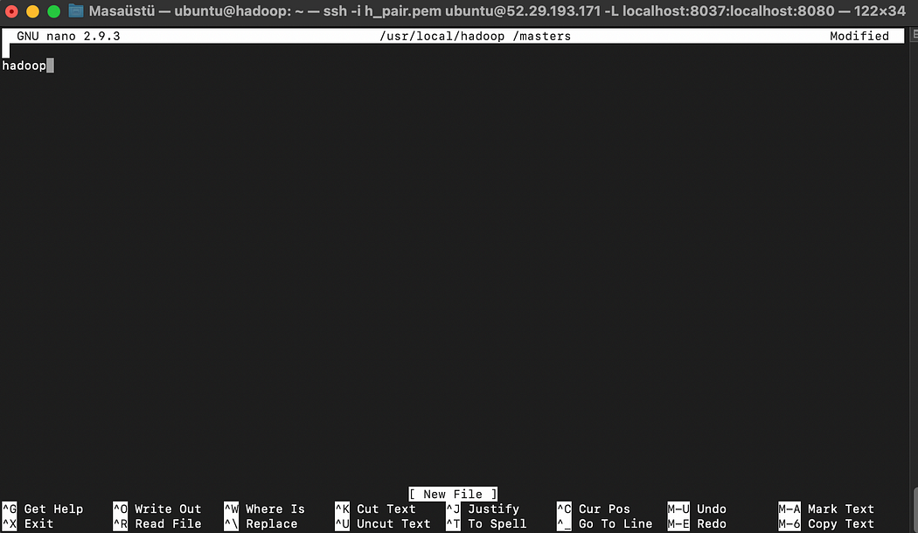

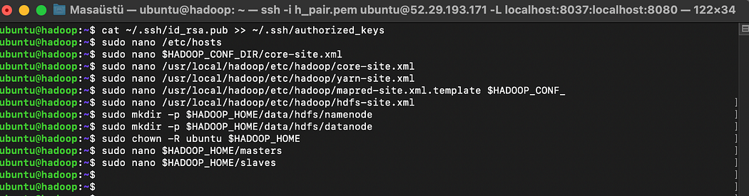

# **Launch Hadoop Cluster**

## **Format and start hdfs**

hdfs namenode -format

$HADOOP_HOME/sbin/start-dfs.sh

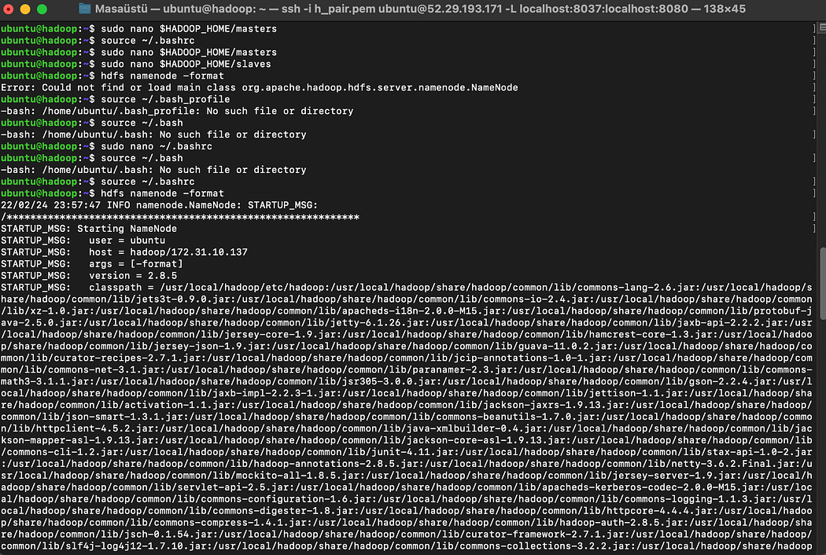

## **Start yarn**

$HADOOP_HOME/sbin/start-yarn.sh

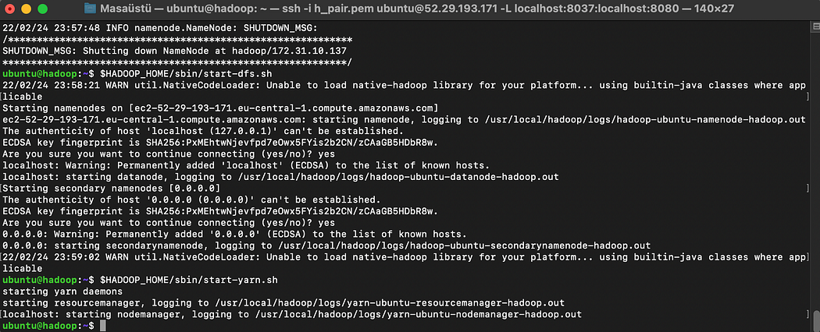

## **Start the job history server**

$HADOOP_HOME/sbin/mr-jobhistory-daemon.sh start historyserver

## **To see the Java processes**

jps

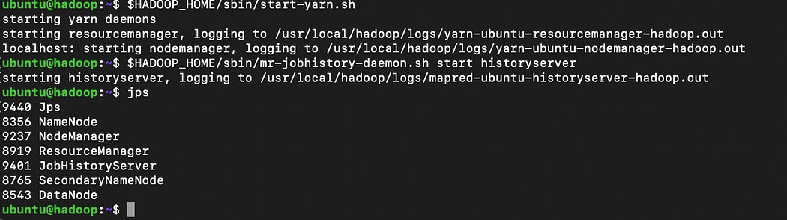

# **Accessing NameNode using WebUI**

## **Namenode Overview**

publicdns:50070

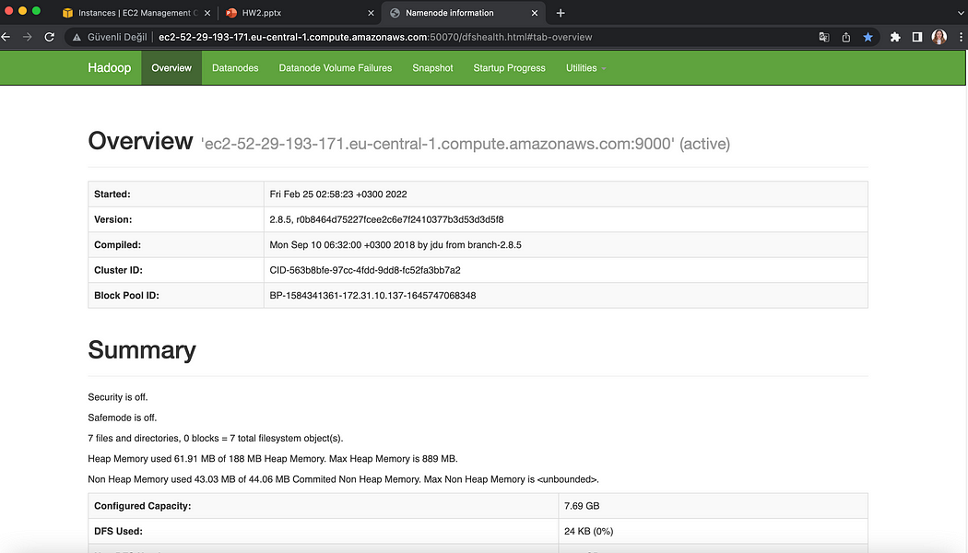

## **Cluster Metrics Overview**

publicdns:8088

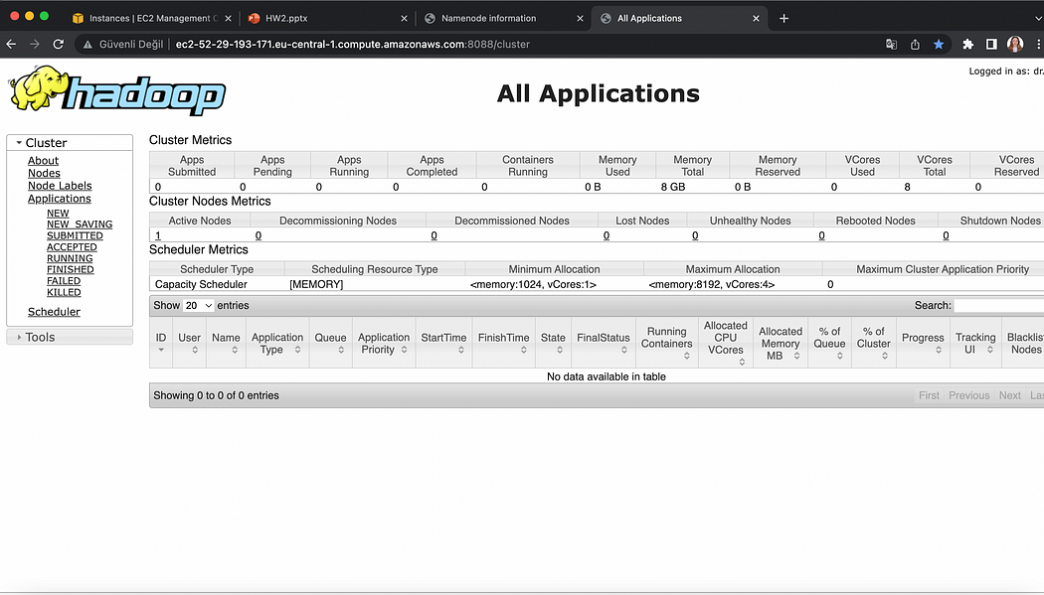

# **Running a sample mapreduce**

# **Creating an input file**

nano input

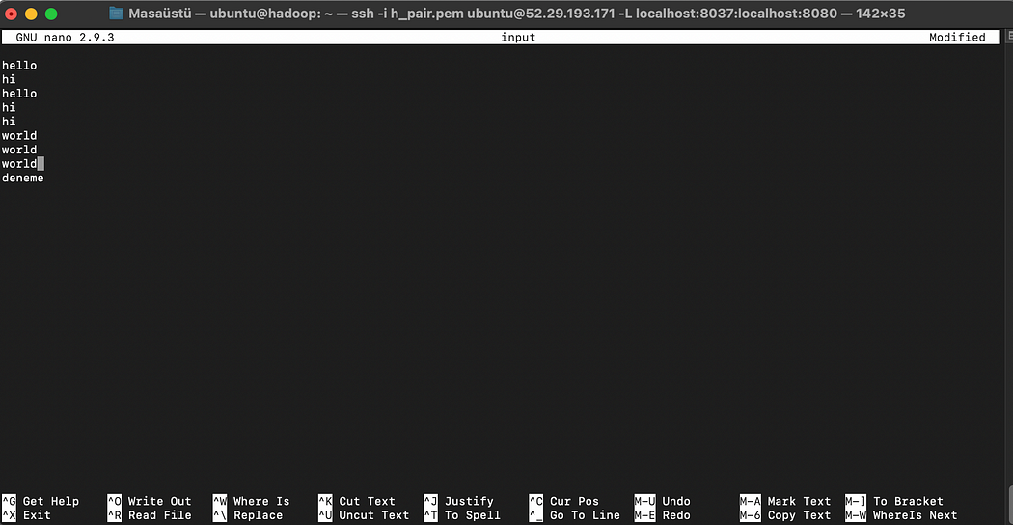

# **Creating a Directory in HDFS and Copying file from Local to HDFS**

hdfs dfs -mkdir -p WordCount/input

hdfs dfs -put input WordCount/input

# **Running MapReduce**

hadoop jar $HADOOP_HOME/share/hadoop/mapreduce/hadoop-mapreduce-examples-2.8.5.jar wordcount WordCount/input WordCount/output

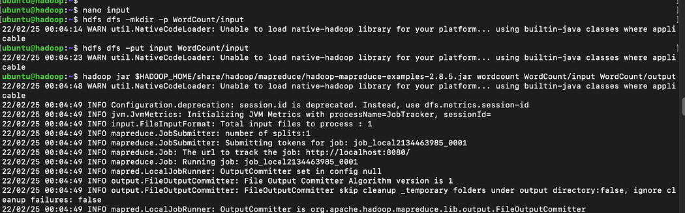

# **Output**

hdfs dfs -cat WordCount/output/part-r-00000

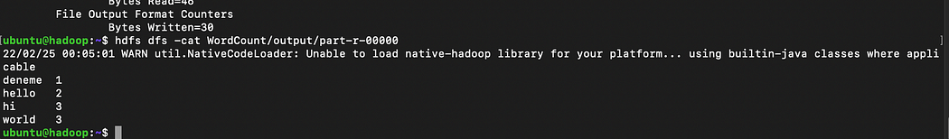

# **Before logout, make sure to stop Hadoop services and AWS Instance**

$HADOOP_HOME/sbin/mr-jobhistory-daemon.sh stop historyserver

$HADOOP_HOME/sbin/stop-all.sh

